Content Creation Using Amazon Web Services

Srijita Bhattacharjee
B.Tech Electronics and Communication Engineering
Vellore Institute of Technology, Vellore, Tamil Nadu, India
Email: Srijita.a2023@vitstudent.ac.in
Prof. Shriharipriya KC
Email:sriharipriya.kc@vit.ac.in
Department of Electronics and Communication Engineering, VIT

Abstract
The rapid growth of artificial intelligence and serverless computing has led to scalable, low-maintenance, and effective pipelines for automated content generation. This research outlines the design and implementation of a fully serverless AI-driven content generation system built on Amazon Web Services (AWS). The proposed structure allows users to enter text prompts through a web-based frontend. This action activates an AWS Lambda backend to create AI-generated images and captions using Amazon Bedrock models like Titan Image Generator and Stable Image Ultra. The generated image is stored in Amazon S3, while AWS Rekognition pulls out descriptive metadata, including labels and hashtags. All contextual data, such as prompts, generated captions, metadata, and presigned URLs, is organized and retrieved from Amazon DynamoDB. The system uses API Gateway for secure communication between the frontend and backend, and Amplify for hosting the user interface. This study shows how generative AI and AWS serverless services can work together to create a cost-effective, scalable, and fully automated content generation pipeline. The results highlight efficient data flow, low operational costs, and flexible deployment, showcasing the architecture's potential for real-time AI content creation and multimedia use.

- Introduction
The rapid growth of artificial intelligence (AI) and cloud computing has led to systems that can create highly realistic and contextually relevant multimedia content. Traditional AI-based generation workflows often depend on complicated arrangements of computing resources and manual management of infrastructure. These methods can lead to challenges related to scalability, maintenance, and costs. To overcome these issues, serverless computing offers a practical solution. It removes the need for constant server management and lets developers concentrate on application logic and features.
This research presents a completely serverless AI content generation pipeline built using Amazon Web Services (AWS). It combines generative AI models with a dynamic, event-driven backend. The system takes a user-provided text prompt through a web interface hosted on AWS Amplify. This action triggers backend processing through AWS Lambda and API Gateway. The application uses Amazon Bedrock to access text-to-image models like Titan Image Generator and Stable Image Ultra for realistic image creation and narrative-style captions.
The output images are securely stored in Amazon Simple Storage Service (S3). Here, AWS Rekognition further analyzes the images to pull out descriptive tags and labels. This metadata, along with prompts, captions, and related presigned URLs, is stored in Amazon DynamoDB for effective data organization and retrieval. The serverless design supports auto-scaling, high availability, and low cost, making it ideal for dynamic content generation settings.
The purpose of this study is to show how combining AWS serverless components with AI services creates a complete zero-maintenance, cloud-native setup for multimedia creation. By explaining the system architecture, implementation flow, and service integration, this paper presents a strong framework for AI-powered creative automation. It also covers performance insights, challenges encountered during implementation, and ways to enhance efficiency, scalability, and security for similar projects in the future.

- Methodology
1. System Design and Architecture
The architecture follows a completely serverless design with the following main components:
Frontend (AWS Amplify): The user-facing interface is hosted on AWS Amplify. It contains index.html, style.css, and script.js. Users can submit text prompts and view the generated content.
API Gateway: This serves as a secure entry point for requests from the frontend to AWS Lambda functions. It ensures controlled access and data routing.
AWS Lambda Functions: These are the main processing units for executing business logic. They handle user requests, call AI models, process outputs, and connect with other AWS services.
Amazon S3: This manages the storage of generated images. Users access them through secure presigned URLs.
Amazon DynamoDB: This keeps structured records for each generation session, including the prompt, captions, hashtags, labels, and image URLs.
Amazon Bedrock: This offers AI-powered content generation using pre-trained models like Titan Image Generator or Stable Image Ultra for text-to-image and caption creation.
Amazon Rekognition: This extracts metadata by identifying objects, scenes, and concepts in generated images. It creates relevant hashtags and descriptive labels.
2. Data Flow and Process Execution
A user enters a text prompt on the Amplify-hosted web interface.
The frontend sends the prompt through API Gateway to an AWS Lambda function.
Lambda calls the Amazon Bedrock model to generate the image and multiple AI-generated captions.
The resulting image is uploaded to Amazon S3, which returns an object key. Lambda then creates a presigned URL for secure access.
Lambda invokes AWS Rekognition on the S3 object to extract semantic labels and hashtags. All data, including the prompt, captions, labels, presigned URL, and image ID, is stored in Amazon DynamoDB for structured access.
The frontend then requests stored metadata from the backend to dynamically display the generated image, captions, and tags.
3. Database Design and Data Management
DynamoDB uses a NoSQL schema with the following key attributes:
Primary Key: ImageID (unique identifier)
Attributes: Prompt, Captions[], Labels[], Hashtags[], S3_URL, Timestamp
This schema allows flexible query performance and easy retrieval of multiple captions or metadata sets per image. It supports the “Next Caption” functionality on the frontend.
4. Security and Access Control
The project includes several AWS-native security features:
IAM Roles and Policies: These grant minimal required permissions to Lambda functions and other services.
Presigned URLs: These ensure temporary and authenticated image access through S3.
API Gateway Authorizers: These enforce secure communication between the client and backend.
CloudWatch Monitoring: This tracks API calls, execution times, and logs for detecting anomalies.
5. Scalability and Optimization Strategies
Lambda’s automatic scaling handles different workload demands without manual intervention. Additionally, Amazon S3 offers nearly unlimited storage scalability. DynamoDB’s on-demand capacity mode adjusts read and write throughput based on traffic. This setup ensures the entire content generation process stays efficient, responsive, and cost-effective.

- System Architecture
The entire system is designed as a modular, serverless architecture. It is hosted on AWS cloud services and is integrated with open AI APIs.

- User Frontend (AWS Amplify):
The frontend, deployed on AWS Amplify, offers users an easy interface to submit prompts and view generated AI results. It ensures high availability, automates version updates, and integrates with backend services for reliable and scalable user experiences.
- API Gateway:
Amazon API Gateway serves as the secure entry point for requests from the frontend, validating and routing each user prompt to the backend Lambda function. It enforces rules for authentication and traffic control, protecting the system from unauthorized or excessive access while making API management easier.
- AWS Lambda (Orchestration):
AWS Lambda is the main orchestrator, executing application logic for each prompt. It coordinates calls to Amazon Bedrock for generative AI tasks, Amazon S3 for image storage, and DynamoDB for organizing metadata, with auto-scaling that eliminates the need for server maintenance.
- Amazon Bedrock (Image & Caption Generation):
Bedrock uses generative AI models to turn prompts into detailed images and multiple captions. This approach allows immediate access to powerful AI capabilities, simplifying content creation within the workflow.
- Amazon S3 (Storage & Presigned URLs):
Generated images are uploaded to Amazon S3, which provides scalable storage and ensures durability. Lambda creates presigned URLs for secure and temporary access from the frontend, protecting image assets from direct exposure.
- AWS Rekognition (Image Analysis):
Rekognition analyzes stored images and automatically extracts labels, objects, and hashtags for rich metadata. This step enhances discoverability and supports advanced user features by providing detailed descriptions of each generated image.
- Amazon DynamoDB (Metadata Storage):
All metadata—including prompts, captions, labels, hashtags, and presigned URLs—is recorded in DynamoDB. This NoSQL backend supports fast and flexible querying, which is essential for displaying and cycling through captions on the frontend.
- Frontend Data Retrieval & Display:
The frontend retrieves metadata and image URLs securely using API Gateway, then displays the results with interactive features like a “Next Caption” button. This allows users to cycle through multiple captions and explore tags in real time.

- Literary Survey
1. Robertson wrote about this in 2025, in his piece called The Rise of Serverless AI, Transforming Machine Learning Workflows. He lays out a protocol along with a workflow design, all aimed at putting serverless AI into practice on AWS. The study points out how serverless setups could really change things in machine learning workflows. Still, it falls short because there is no big, real-world testing to back it up.

2. Kobal put out his work in 2024, titled Serverless AI Agents in the Cloud. He looks into architectures that scale well and use agents for rolling out AI systems on serverless platforms. This gives a solid model for spreading out intelligence in a distributed way. The thing is, it runs into problems with how complicated it gets to manage multiple agents without wasting effort.

3. There is this article from SIGARCH in 2025, named AI Goes Serverless, Are Systems Ready. It dives into innovations at the systems level that make it possible to deploy custom AI models without servers. The findings come from experiments, though. They do not draw from full production systems on a large scale, so the practical takeaways stay somewhat limited.

4. Joynt and his team came out with their paper in 2024, called Comparative Analysis of Text-to-Image Generative Models. They run experiments comparing basic AI models to check performance across different setups. The analysis offers some good insights into what works. Even so, it stays held back by tests on a small scale and not much chance to apply it more widely.

5. Wang and others published in 2024, in Advancing Serverless Computing for Scalable AI Model Inference. They go over various methods for handling inference from large language models in serverless setups. The survey covers a lot of ground in a thorough way. That said, it flags ongoing troubles with latency and managing resources as the main weak spots.

6. Gondosubroto shared his thoughts in 2025, through Generative AI Applications with AWS. He gives hands-on tutorials that use AWS Bedrock and basic models, focusing on real applied scenarios. The material shines in its teaching side. On the other hand, it leans more toward guidance than any deep empirical checks or side-by-side comparisons.

7. Handoko and colleagues did their study back in 2022, in Amazon Rekognition Labels Adds 600 New Labels. They test out how well Amazon Rekognition pulls metadata from images. This adds fresh looks at performance metrics. It stays pretty focused on benchmarks alone, though. That keeps it from reaching into wider areas of AI work.

8. Tari explored this in 2024, in Auto-scaling Mechanisms in Serverless Computing. He checks out and sorts different strategies for scaling in serverless AI setups. The taxonomy he builds turns out useful for understanding options. It does not go all the way to showing or proving a full stack from start to finish.

- Services Used
The services used to make a functional app are AWS Bedrock, AWS lambda, AWS S3 Bucket, AWS DynamoDB, AWS Rekognition, AWS API Gateway, Github Repository and AWS Amplify. 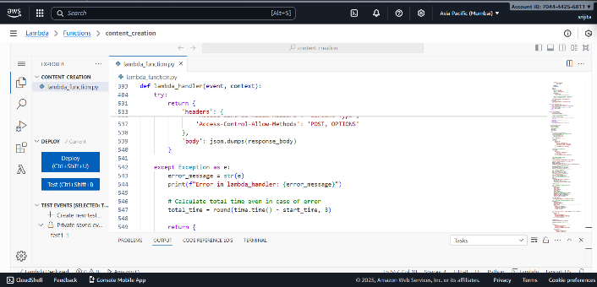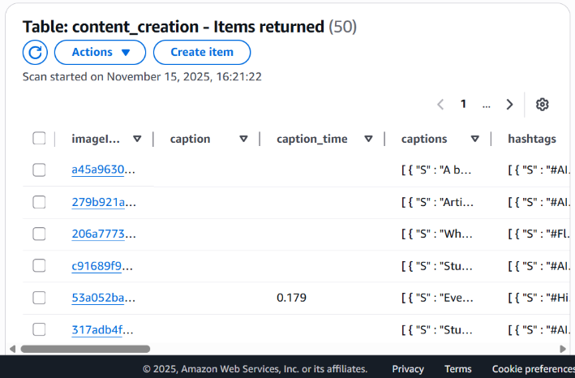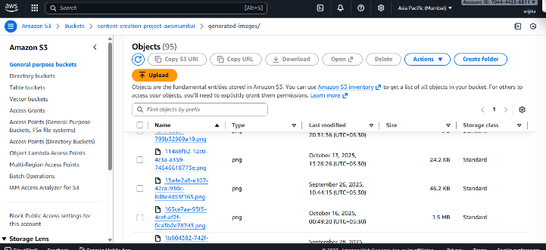
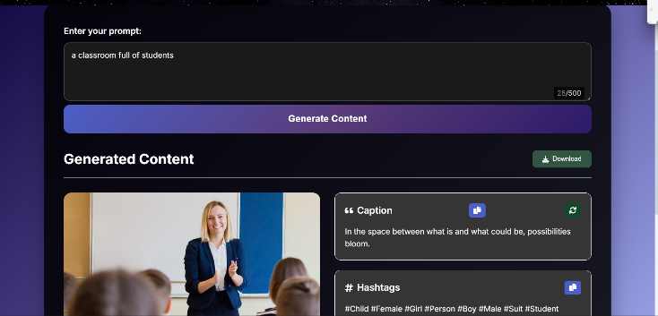
- Results
The serverless AI content generation system successfully combines AWS services to create a fully automated process for generating images, captions, extracting metadata, and ensuring secure content delivery.
- Image and Caption Generation:
The system produced realistic images and various story-style captions based on different user prompts. Using Amazon Bedrock models like the Titan Image Generator and Stable Image Ultra, the outputs showed strong relevance to the context and high visual quality, making them suitable for multimedia use.
- Metadata Extraction and Storage:
AWS Rekognition identified objects, scenes, and attributes in the generated images, creating detailed labels and hashtags. This metadata was stored along with image URLs and captions in DynamoDB, allowing for easy retrieval and flexible display on the frontend.
- Frontend Interaction and User Experience:
The frontend, hosted on AWS Amplify, had quick response times and allowed users to cycle through multiple captions for each image using the “Next Caption” button. Users could easily see the generated images along with their metadata, creating an engaging content exploration experience.
- System Performance and Scalability:
The serverless setup automatically adjusted to user demand, with AWS Lambda managing prompt processing and AI model calls without needing manual server setup. Amazon S3 provided reliable and scalable storage for images, while presigned URLs offered secure, temporary access to those images.
- Security and Access Control:
IAM roles and policies enforced limited access, and API Gateway secured communications between the frontend and backend. Using presigned URLs reduced the risk of exposing stored images.Overall, this system demonstrates how AWS serverless tools can work together to create an efficient, scalable, and secure AI content generation process. The outcomes illustrate practical use for real-time creation and delivery of AI-generated multimedia content with enhanced metadata.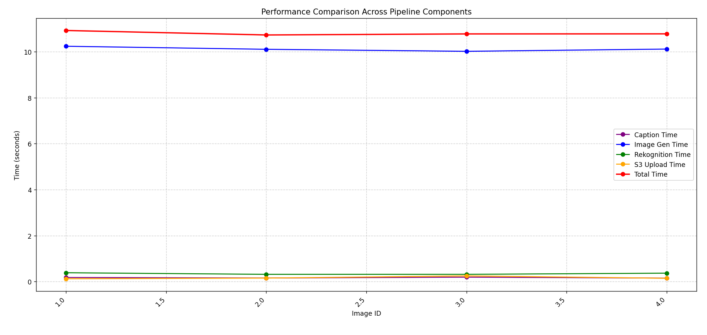
VII. Conclusion
This study shows how to practically implement and benefit from a serverless AI content generation system that uses Amazon Web Services. By using AWS Lambda, Amazon Bedrock, S3, API Gateway, Rekognition, and DynamoDB, the system automates, scales, and secures generative AI workflows for real-time multimedia creation. The setup allows for responsive, event-driven processing while removing the need for managing infrastructure. This reduces operational costs and makes it easier for developers to work with.
The results show great flexibility and reliability. The system generates images and captions effectively, enriches metadata automatically, and delivers content securely through presigned URLs and strict IAM controls. By integrating AWS serverless services, the system can scale dynamically to meet changing user needs and allows for easy future upgrades.
Overall, this approach proves that AWS serverless frameworks work well for creating intelligent, production-ready AI content pipelines. The system sets the stage for future efforts to improve real-time inference, explore new foundational models, and expand metadata enrichment for more advanced applications in digital media, education, and e-commerce.
- References
[1]Robertson, J., “The Rise of Serverless AI: Transforming Machine Learning Workflows,” InternationalJournal of Computer Science & IT, 2025.​
[2]Kobal, O., “Serverless Ai Agents in the Cloud,” Automatic Control and Computer Science, 2024.​
[3]SIGARCH, “AI Goes Serverless: Are Systems Ready?” SIGARCH Blog, 2025.​
[4]Joynt, V. et al., “Comparative Analysis of Text-to-Image Generative Models,” IRJET, 2024.​
[5]Wang, L. et al., “Advancing Serverless Computing for Scalable AI Model Inference,” ACM Computing Surveys, 2024.​
[6]Gondosubroto, R., “Generative AI Applications with AWS,” Manning Publications, 2025.​
[7]Handoko, M. et al., “Amazon Rekognition Labels adds 600 new labels including landmarks and now detects dominant colors,” AWS Machine Learning Blog, 2022.​
[8]Tari, M., “Auto-scaling mechanisms in serverless computing,” Journal of Cloud Computing, 2024.​
[9]AWS Documentation, “Amazon Bedrock – Generative AI,” https://aws.amazon.com/bedrock/, 2025.​
[10]AWS Documentation, “Amazon Rekognition,” https://aws.amazon.com/rekognition/, 2025.​

